

April 16, 2013

To:

Head Start and Parents of enrolled children

Professor Greg Larson and Business Communication Colleagues

Salt Lake Community College, Redwood Campus

Salt Lake City, Utah

Re:

Mission Read to a Child

Dear reader,

Enclosed you will find a Managerial report for Mission Read to a Child, questionnaire, literacy statics, and secondary research on the benefits of reading to child. In this report you will find information gathered on the need to encourage children to read.

Mission Read to a Child is a project designed by a group of students from Salt Lake Community College to raise awareness with adults that they have the opportunity to influence the learning potential of children by reading to them. Our mission is also to provide books donated by the community to help accomplish this goal.

We believe that this project will serve a population of under privileged children and special needs children. That this will encourage their parent’s involvement in a new vision of how the power of reading can benefit their children.

Thank you for your support in the process of better educating our children.

Sincerely,

Mission Read to a Child team:

_______________________________ _______________________________

Brook Durman Cindy Jones (CJ)

_______________________________ _______________________________

Rebecca Lomas Ronda Lopez

_______________________________ _______________________________

Julie Ockler Cyndi Wheatley

**Mission to Read to a Child**



***Reading Beyond the Classroom***

Prepared for

Head Start

Parents of enrolled children, and

Salt Lake Community

Prepared by

Brooke Durman

Cindy Jones (CJ)

Rebecca Lomas

Ronda Lopez

Julie Ockler

Cyndi Wheatley

Salt Lake Community College

Business Communications 2200

April 29, 2013

**Executive Summary**

*Mission Read to a Child* was established by a group of students from Salt Lake Community College as a project for our Business Communications 2200 class. It was designed around the idea to raise awareness with parents and adults that they have the power to influence the learning potential of children by reading to them or with them. We saw an opportunity to motivate parents to read to their children as they would have more books available to them.

It is proven that reading and writing begin in their homes before children ever start to attend school (Morrow). We would like to help create and maintain that learning environment by donating books to families. This is one of the ways that Mission Read to a Child is committed to maximizing the potential of children who are eager to learn before they ever reach a classroom. Sustaining a healthy reading environment is also key in keeping children engaged in reading to expand their reading and comprehension skills once they are out of a classroom learning environment.

Our mission is to access books through different channels that are willing to donate. We then turn those books over to families that would allow them to sustain a healthy reading atmosphere for their homes, with their families.

Our group randomly sampled 102 people to find out if they thought that reading is important in this community. When asked if reading is for fun, learning or both, 75% of our respondents said “both.” We also found that there was almost a direct correlation to those that said if there were more books available to their children, they would read more to them (Figure 1).

Figure 1

Figure 2

We do believe that this project will serve a population of under privileged children and that getting their parents involved will encourage a new vision of what the power of reading can do.

**TABLE OF CONTENTS**

**Tab Number**

Executive Summary……………………………...

Introduction……………………………………… 2 Pages 5-6

Analysis of Findings…………………………….. 3 Page 7

Literacy statics…………………………… Page 8

Questionnaire results…………………….. Pages 9-10

Conclusions and Recommendations…………….. 4 Page 11

References……………………………………….. 5 Page 14

Appendices A ……………………………………. 6 Pages 14-??

Sample of Questionnaire…………………. Page 14

Questionnaire results……………………... Page 15

Appendices B……………………………………... Page 16-

Head Start information……………………. Page 16

Additional articles on reading to children…

**Introduction: Mission Read to a Child**

**Overview:** Utah’s First Lady, Jeanette Herbert, stated, **“**86 percent of all juvenile offenders have reading problems, and 60 percent of prison inmates are illiterate” (Herbert). Based on the research by the National Institute of Child Health and Human Development (NICHD), the website [Homework Help Secrets](http://www.homework-help-secrets.com/importance-of-reading.html) indicates, “Reading is the single most important skill necessary for a happy, productive and successful life. A child that is an excellent reader is a confident child, has a high level of self-esteem and is able to easily make the transition from learning to read to reading to learn” (Home Work Help Secrets).

**How does this relate to our Business Communications Project? This will be a service learning project.** I propose arranging collections of new or gently used books at our places of employment and/or here at Salt Lake Community College. The Books collected will be delivered to The Children’s Reading Foundation of Utah, a non-profit organization, for distribution to the hands and homes of children.

**Research Questions:** How do we get the word out? What will be most effective? Do we use multiple means of *advertising*? Some ideas of *advertising* are: emails, brochures, announcements, verbal (word of mouth), etc.

**Rationale:** The process of gathering information and collaborating with other professionals for this project will bring experience to those on the team. Team members can feel good knowing they will help bring positive change to the future of many children. This will be a project that will require many different skills in business communications to collaborate with businesses and SLCC.

**Feasibility:** Since there are so many families who purchased books for their children and those children subsequently have outgrown those books, there are an abundance of lonely books on shelves, in closets, and in boxes waiting to be enjoyed again by other children. Due to this fact, it shouldn’t be difficult to convince our employers and SLCC to allow advertisement of Mission Read to a Child.

Salt Lake City, head start programs assists our community’s underprivileged and special needs children with educational needs. Join us in donating gently used books to empower children to read. To find more information on head start locations in Salt Lake City go to: saltlakeheadstart.org.

An article written by Angela Brown, “How to Get Book Donations”, that gives six steps in collecting books for donations. A couple of suggestions in her list are: posting announcements about your drive and how people can donate in local sections of free online classified sites (she references Craig’s List) and calling local bookstores, libraries, and schools to see if they have unwanted or unneeded books they would like to donate (Brown).

“The importance of reading with children” is an article by Cecily Markland that outlines the importance of reading with children (just like the name says). It states why it is so important for infants, toddlers, and children to be read to daily. Statistics are given on those who are read to daily and those who are not (Markland).

**Materials and Methods:** The team will need to decide on which will be their most effective means of communicating the importance of book donations and how many different communication avenues they will use get the books. Team members will be assigned getting contacts from their employers and/or SLCC to collaborate and get permission to distribute the *advertisements*. The costs of printed *advertisements* could be kept to a minimum if emails with attachments are mainly used with only a handful of printed *advertisements* for each place of business. Boxes or bins will be needed for collection of the books.

**Personnel:** Since this is a service learning type project that is based on collecting donations for a good cause, the communicating will mostly be with companies from whom we work for, SLCC, friends and family to solicit the donations. In order for us to collect an outstanding amount of books, our team of 6 members; otherwise we’ll have an extremely low count of donations to gather from. Each team member would be equally involved in the design of *advertisements* and they would be responsible for one company to collaborate with (their own or SLCC).

**Time Frame:**

* Weeks One - gather information, discuss the *advertising* options, and compile a list of companies to offer Mission Read to a Child
* Week Two - determine what methods of *advertising* will be most effective and commit to those methods
* Week Three - Discuss what means can be used at each business by discussing them with each business contact, start design of *advertisements*
* Week Four - Complete *advertisement* designs and print as necessary
* Week Five - Post advertisements at the various businesses
* Week Six - Remind businesses of Mission Read to a Child and begin preparing for class presentation
* Week Seven – Collect books and deliver to the non-profit organization, Children’s Reading Foundation of Utah, finalize presentation and PowerPoint files
* Week Eight - group presentations

**Hurdles:** The biggest challenge ahead is coordinating time with team members with work and school schedules. This will be a time consuming assuming project but in the end very satisfying. Asking for donations may be new to some of us and because of that, it may be uncomfortable. By asking for these donations, it will bring experience to this area of service type work.

**Findings**

Reading is paramount to an individual’s academic success and personal accomplishments; therefore, early literacy development is essential.

* Early exposure to reading provides children with knowledge and literacy skills which are critical for the development of a strong academic and social foundation (Swick 2009; Morrow 2001).
* Students who fail to master the basic reading skills at an early age are at a greater disadvantage for reading failure (Lane et al. 2002; Joseph and Schisler 2006; Paige 2006).

Research indicates that 74% of students identified with reading deficits in third grade continue to experience significant reading difficulties in ninth grade. Hence, the inability to read at grade level in middle school has been linked to failure to master the basic reading skills (primarily fluency and comprehension skills) in the early grades (Rasinki and Padak 2005).

* When students lack confidence in their reading ability, they develop negative attitudes toward reading.
* However, students with well-developed foundational skills become skillful readers who continue to increase their reading success in later years (Juel and Minden-Cupp 2000; Lane et al. 2002).

Children’s early exposure to and participation in literacy activities with parents in rich home literacy environments is one of the most important elements in their emergent literacy as well as development and educational out-comes (Leseman and de Jong 1998). Strickland (1989) found that children who come from homes where storybooks are read to them have advantage over children who are not read to at home. Additionally, Weigel et al. (2006) noted, “Parents who express positive attitudes about reading and activities are creating an atmosphere of enthusiasm for literacy and learning” (p. 374).

These early positive experiences with reading serve as a stepping stone for further literacy development. Children will see reading as an enjoyable process and become familiar with the skills that make them ‘‘preschool ready’’. Having books and resources readily available will allow them easy opportunities to read and practice their skills at home.

**Literacy statics**

The literacy statics are from a study done by RIF Reading is Fundamental, Reach out and Read. Their mission is literacy programs based on distinct program models to create a continuum of literacy development.

* **80% of preschool and after-school programs serving low-income populations have no age-appropriate books for their children.**
* **The most successful way to improve the reading achievement of low-income children is to increase their access to print.**
* **Findings show higher-than-average scores among students who reported more types of reading material at home.**
* **Creating a steady stream of new, age-appropriate books has been shown to nearly triple interest in reading within months.**
* **Almost 13 million American children live in poverty**
* **78% of juvenile crime is committed by high school dropouts.**
* **37 percent of children arrive at kindergarten without the skills necessary for lifetime learning.**
* Children from low-income families are at greater risk for entering school unprepared.
* **By the age of 2, children who are read to regularly display greater language comprehension, larger vocabularies, and higher cognitive skills than their peers.**
* The Early Childhood Longitudinal Study found that in the spring of 2000, the children who were read to at least three times a week by a family member were almost twice as likely to score in the top 25% in the reading compared to children who were read to less than 3 times a week.

(RIF Reading is Fundemetal, Reach out and Read)

“This graph shows only entering third graders. Out of 100 students entering third grade, 14 of them still read at a kindergarten level, 15 at a first-grade level, and 3 of them at a seventh or eighth grade level”, see figure 2 below. (Children's Reading Foundation)**.**

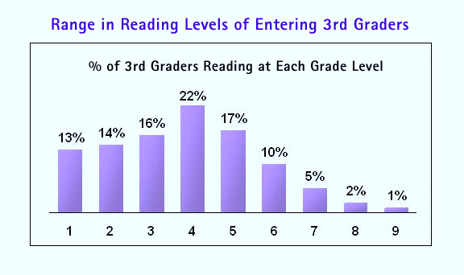

(Children's Reading Foundation)

Figure 2

**Questionnaire Results**

Our group Read to a Child, randomly sampled 102 people with a questionnaire that asked ten questions. The purpose was to find out how parents thought about the importance of encouraging their children to read.

As part of the questionnaire our group needed to know the age group of children at home shown in figure 3, for our random sample. Then if the parents believed reading is for learning or fun or both in figure 4 are the results.

Figure 3

Figure 4 question 2

In these questionnaire we did find a correlation between time periods spent reading and how many times a week spent reading. In figures 5 and 6 shows the frequency or lack of frequency of time spent reading to a child.

Figure 6

Figure 5

**Conclusion and Recommendations**

Read Every Day = Lead a Better Life

If you had more books in your household would you read to your child?

**Statistics:**

* Only 31 percent of college graduates have high level literacy skills
* Students who don't read proficiently by third grade are four times more likely to leave school without a diploma when compared to proficient readers. The number rises when those kids also come from poverty

**Benefits of reading to your child:**

* Children learn an average of 4,000 to 12,000 new words each year as a result of book reading.
* Children living in poverty, on the whole, have a greater summer learning loss than do children from affluent families, and those students living in poverty that did have gains over the summer, had smaller gains than their peers whose families had higher incomes.
* Children who grow up in homes where books are plentiful go further in school than those who don't. Children with low-education families can do as well as children with high-education families if they have access to books at home.

Donating un-used books to children in need helps our future. Reading can be for fun and also for learning. Reading less than an hour a day can help your child succeed.

References

*Children's Reading Foundation*. 1996-2011. http://www.readingfoundation.org/reading_research.jsp. 7 April 2013.

Brown, Angela. *How to Get Book Donations*. 2013. http://www.ehow.com/how_6672477_book-donations.html. 14 April 2013.

*Children's Reading Foundation*. 1996-2011. http://www.readingfoundation.org/reading_research.jsp. 7 April 2013.

Herbert, Jeanette: Utah's First Lady. *Read to Read with a Child*. 2013. http://firstlady.utah.gov/literacy/index.html. 14 April 2013.

*Home Work Help Secrets*. 2009. http://www.homework-help-secrets.com/importance-of-reading.html. 14 April 2013.

Joseph, L., & Schisler, R. "Reading and the whole student." *Principal Leadership (Higher School Education)* (2006): 6, 11-15.

Juel, C., & Minden-Cupp, C. "One down and 80,000 to go: Word recognition instruction in the primary grades." *The Reading Teacher* (2000): 4, 332-335.

Lane, H., Pullen, P., Eisele, M., & Jordan, L. "Preventing reading failure: Phonological awarness assessment and instruction." *Preventing School Failure* (2002): 3, 101-110.

Leseman, P., & de Jong, P. "Home literacy: Opportunity, instructions, cooperation and social-emotional quality perdicting early reading achievement." *Reading Research Quarterly* (1998): 33(3), 296-318.

Markland, Cecily. *The importance of reading with children*. 15 May 2011. “The importance of reading with children” is an article by Cecily Markland. 14 April 2013.

Morrow, L. M. *Literacy development in the early years: Helping children read and write*. Boston, MA: Allyn & Bacon, 2001.

Paige, D. "Increasing fluency in disabled middle school readers: Repeated reading utiliziing above gade level reading passages." *Reading Horizon* (2006): 46, 167-181.

Rasinki, T., & Padak, N. "Fluency beyond the primary grades: Helping adolescent struggling readers." *Voices From the Middle* (2005): 13, 34-41.

RIF Reading is Fundemetal, Reach out and Read. "bookspring Lanching Children into a world of reading." 2013. *http://www.bookspring.org/literacy-statistics/.* 7 April 2013.

Strickland, D. S. "A model for change: Framework for an emergent literacy curriculum. In D.S. Strickland & L. M. Morrow (Eds)." *Emerging Literacy: Young children learn to read and write*. Newark, DE: International Reading Association, 1989. 135-146.

Swick, K. "Promoting school and life success through early childhood family literacy." *Early Childhood Journal* (2009): 36, 403-406.

Weigel, D., Martin, S., & Bennet, K. "Contributions of the home literacy environment to preschool-aged children's emerging literacy and language skills." *Early Child Development and Care* (2006): 176,357-378.

**Appendices A**

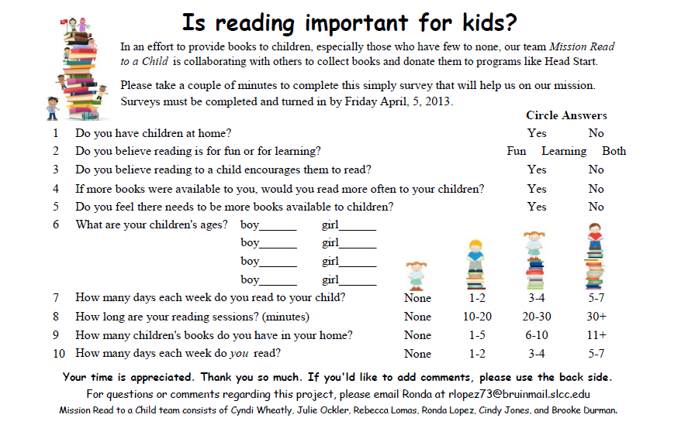

Figure Sample of Questionnaire

Figure 31 question 9

Figure 10 question 5

Figure 8 question 1

Figure 12 question 10

Figure 3 question 6

Figure 4 question 2

Figure 6 question 8

Figure 9 question 4

Figure 7 question 3

Figure 5 question 7

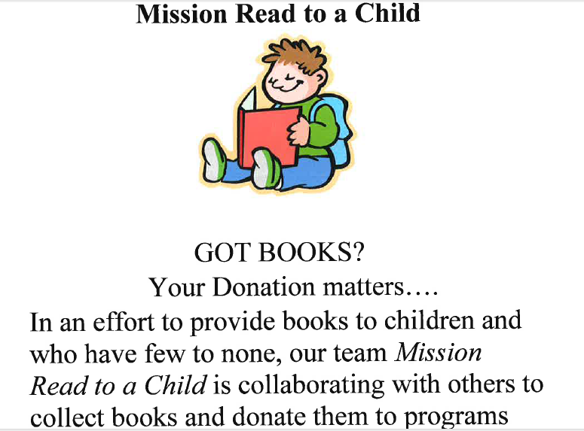

Figure poster for book donations

**Appendices B**

